**1.Write a c program to evaluate TRIE**

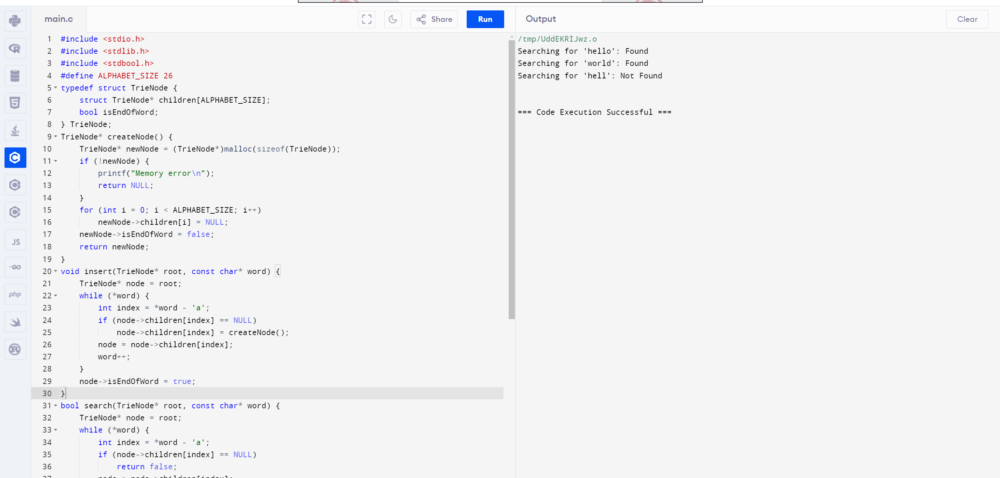

**2.Write a c program to evaluate 2-3 TREE**

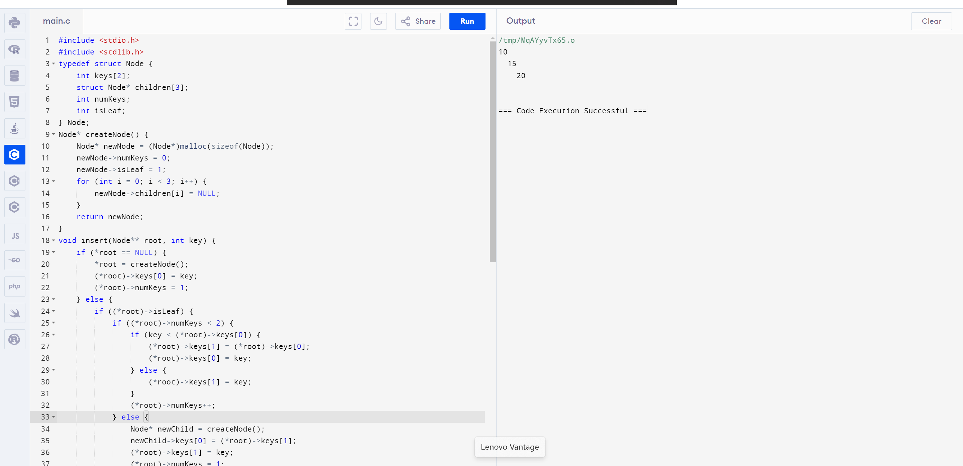

**3. Write a c program to evaluate 2-3-4 TREE**

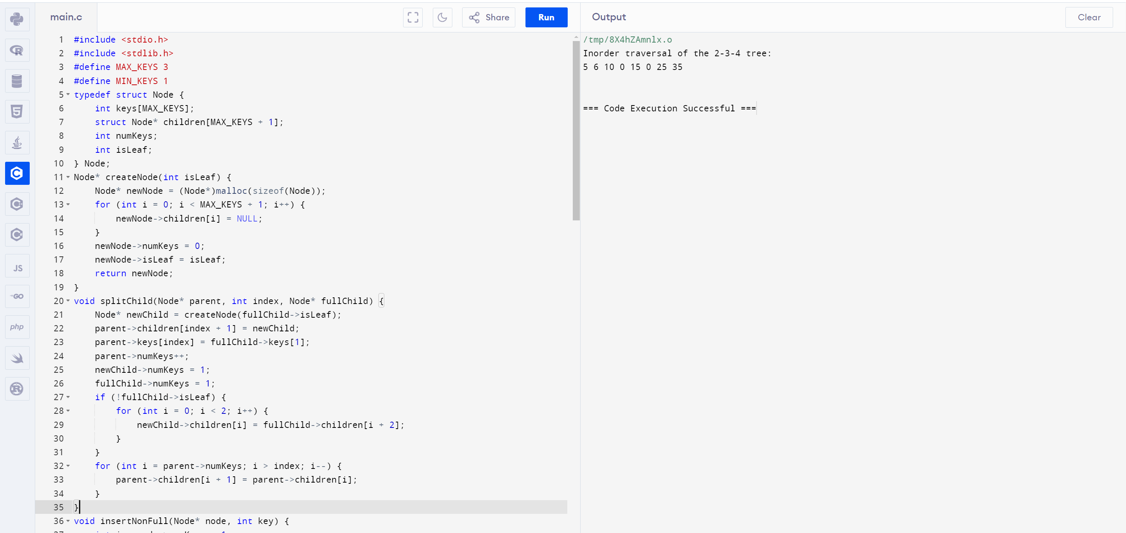

**4. Write a c program to evaluate 2-3-4-5 TREE**

